Brookfield Asset Management Inc. Case Study
Names
Institutional Affiliations
Introduction
This is a case study on the way in which the Brookfield Asset Management Inc. addresses a problem in business method and the way in which it performs any business action. Brookfield Asset Management Inc. is one of the fundamental strategic investors in the world real estate market. The company carries out its investments in high quality commercial real estate globally either directly on the balance sheet of flagship public partnership (Brookfield public partnership) or through private equity real estate funds that are managed by Brookfield. Around 80% of the companies invested capital is in the premier class A retail and office assets in most of the global dynamic and resilient markets such as Europe, Australia, and North America. The other 20% of the capital invested by Brookfield represents Brookfield public partnership’s (BPY) equity participation in the funds that are sponsored by the firm. Notably, the sponsorship includes but not limited to deal sourcing, fundraising, deployment of capital, distribution of liquidity, operations, and winding up of funds. The 2008 financial crises brought about financial problems to the company.
The problem
In the context of a financial crisis, the prices of assets go through a sharp decline in value, consumers and businesses are rendered incapable of discharging their debts, and the financial institutions undergo liquidity shortages. In addition, a financial crisis is usually linked with a bank run or panic whereby investors placer their assets on sale or withdraw money from their savings account due to the fact that they are afraid that the value of their assets will decline if they remain in financial institutions. Moreover, a financial crisis situation is also characterized by the bursting of a speculative financial bubble, crash of the stock market, sovereign default, and currency crisis. The 2008 financial crisis was a scary time for many global real estate companies since there was a crash of the financial markets, money lenders ducked for cover and federal officials who had already panicked scrambled to save the economy. Significantly, the years that ensued caused both opportunities and misery to players in the real estate market.
However, a decade after the crash, most of the huge properties and companies battered by the bust have recovered through debt restructuring and the owners of the bubble-era are long gone. Credit crisis, bank collapse, government bailout, and mortgage crisis are common phrases that hit the headlines throughout the fall of 2008, a period in which most real estate companies lost their value. With its roots in 2008, the subprime mortgage crisis brought about a heavy decline in the market value of Brookfield Investment Inc. as prices broke down to more than 30% (Kotz, 2009). The shareholders of the Brookfield Asset Management Inc. rushed to the exits in the September of 2008 as they were worried that it would be impossible for the company to refinance loans that amounted to more than $4 billion. The troubled housing industry attracted most of the headlines due the role that it plays in touching off the economic slowdown and financial crisis (Ivashina & Scharfstein, 2010). The real prices for offices and buildings also declined and the quality of bank real estate loans deteriorated as shown below.
Table 1: Real prices of offices and buildings
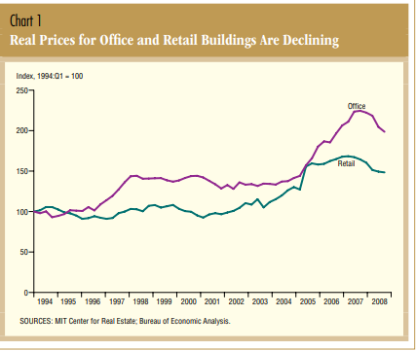
Table 2: quality of bank real estate loans
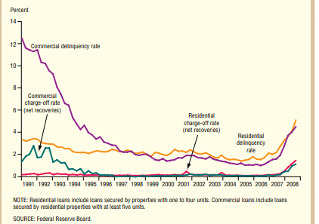
The solution
For the purposes of getting out of financial crises, there is a need for businesses to exert optimum effort. This takes time and resources because it is impossible to overcome a financial crises problem instantly (Crowe, Dell’Ariccia, Igan, & Rabanal, 2013). The fact that 2008 was with no doubt the most challenging year ever in the real estate business due to the financial crisis, Brookfield avoided a large proportion of then investment mishaps that were experienced by other real estate giants. This was due to the kind of long-duration hard assets that are owned by the company.
After overcoming the global financial crisis, the years that came after 2010 displayed a better image of the economic situation. During the crisis, the company’s investment posture was focused on making sure that the firm had adequate capital for the purpose of supporting its existing business, and acquiring the control of new assets and businesses that were offered at intrinsic value. Based on the fact that Brookfield Asset Management Inc. supported a couple of rights offerings and had acquired numerous distressed assets mainly via the repurchase of debt for conversion to equity purposes, the company managed to have a significant expansion of its asset base working for both the clients and shareholders. The company believed that through acquisition of assets through distress circumstances provides one of the limited ways of acquiring assets at significant discounts (Brookfield, 2010).
In addition, the company also employed the capital recycling and non-strategic asset pruning strategy to recover from the global financial crisis, which later helped greatly in the generation of net cash proceeds. For instance, in October 2008 the company sold off part of its 580,000 of freehold lands in the United States Northwest to an institutional investment partnership, where Brookfield manages and retains 40% of both direct and indirect assets. In the process of restructuring, the company further focused on asset classes that are known to have a good experience in making such investments with the ultimate goal of controlling the assets. The company spent the better part of the second half of 2009 dealing with restructuring opportunities. Its most focus was on carrying out investments on the acquisition of distress debt positions or placing itself in a manner that was possible to acquire a couple of distress assets (Brookfield, 2010). Accordingly, the company was able to capitalize on converting these restructuring opportunities to real investments. In addition, the company engaged in extensive fundraising activities and ended up raising $14 billion third-party capital for investment that enabled it to acquire more assets during the recovery phase of the market cycle (Acharya, Rao, Bhattacharjee, & Wright, 2010).
Table 3: Fundraising during the financial crisis
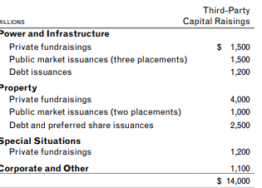
Source: (Brookfield Asset Management Inc. Annual Report 2009)
Notably, regardless of the fact that private fundraising was constrained severely due to the 2008 financial crisis, Brookfield’s flexibility in approaching the market made it possible for the company to close a number of funds. The company has since diversified its portfolio and its financing structure. For instance, Brookfield Asset Management Inc. has a major chunk of business in critical infrastructure such as power, telecom, and utilities, which continue to remain in operation in times of crises. Making a comparison between the current economic mayhem orchestrated by COVID-19 and the 2008 financial crises, Brookfield is in position to manage the current volatility and uncertainty since the financial system is still in good shape. During the tough times, the company has since planned to maintain sufficient capital for a worse-case scenario. Further, the company can also plans to repurchase its old stock at depressed prices due to the fact that the management is certain that the prices will still recover in future.
Conclusion and Recommendation
The global financial crisis that occurred in 2008 had a negative influence on the real estate and financial markets. In addition, the increased costs and reduced accessibility to financing had negative consequences to the commercial real estate markets and secondary impacts on investors and bank. Some of the well-established real estate markets were on the brink of bankruptcy with some filing for bankruptcy protection. However, the Brookfield Asset Management Inc. managed to maneuver due to its resilience, flexibility, and business methodology. While in business, it is always important to understand that major crisis will always come out of distortions due to the level of global financial system. Moreover, learning from past mistakes and also from successful actions can largely assist in enhancing the design of institutions, regulation of the market, and policies, which would therefore help in reducing the virulence and incidence of financial crises. Another way of overcoming financial crises problems is through determining the cause of the financial crises in order to come up with a permanent solution. In addition, it is important to review the sales strategies to establish whether they work or not. This can be done by evaluating the marketing initiatives. It is also important to consider value investing.

References
Acharya, R. C., Rao, S., Bhattacharjee, S., & Wright, L. (2010). Outward FDI from Canada and its policy context. Transnational Corporations Review, 2(3), 28-43.
Brookfield (2010). Annual Report 2009. [Online] Available at: https://bam.brookfield.com/reports-and-filings/financial-reports/annual-reports/2009
Crowe, C., Dell’Ariccia, G., Igan, D., & Rabanal, P. (2013). How to deal with real estate booms: Lessons from country experiences. Journal of Financial Stability, 9(3), 300-319.
Ivashina, V., & Scharfstein, D. (2010). Bank lending during the financial crisis of 2008. Journal of Financial economics, 97(3), 319-338.
Kotz, D. M. (2009). The financial and economic crisis of 2008: A systemic crisis of neoliberal capitalism. Review of radical political economics, 41(3), 305-317.

